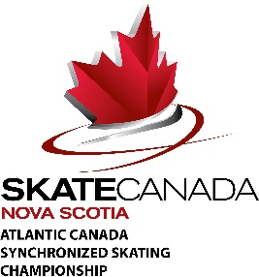
Synchro Team Summary Form

Category: Click here to enter text. Team Name: Click here to enter text.
Club: Click here to enter text.
Coach(es): Click here to enter text.
Club Contact Person/Team Manager: Click here to enter text.
Club Contact Email: Click here to enter text. Club Contact Phone #: Click here to enter text.

Team Members
Name | Date of Birth | Skate Canada Number

Team Alternates
Name | Date of Birth | Skate Canada Number

*Please return completed forms to Jill Knowles skatecanadans@sportnovascotia.ca or fax 902-425-5606

