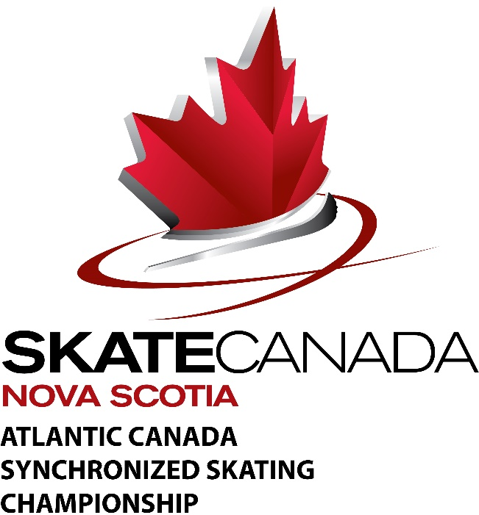

ATLANTIC REGIONAL SYNCHRONIZED SKATING CHAMPIONSHIP

JANUARY 27/28, 2018

Sanctioned by Skate Canada. Rules in accordance with Skate Canada.

HOST Skate Canada Nova Scotia and the Queens County Blades

ARENA LOCATION & ICE SURFACE

Queen’s Place Emera Centre, 50 Queen’s Pl Dr, Liverpool, NS
Dimensions of Stadium: 85 feet x 200 feet

ELIGIBILITY TO COMPETE (From Skate Canada Rule 5401)

Entrants in events shall be:
eligible persons as defined in Skate Canada Rule Book Section 2100.
- Associate Members in good standing of the Association.

ENTRIES AND FEES

The closing date for entries is Sunday December 17th 2017 All entries must be completed online through the Skate Canada Nova Scotia Uplifter link. Skatecanadans.uplifterinc.com. NO late entries will be accepted. NO refunds will be issued. Registration opens Monday December 11th 2017. You must set up an account with Skate Canada Uplifter to register.

Entry fees are:
Beginner I $175 plus $20 per skater including alternates
Beginner II
Elementary

PreJuvenile $250 plus $20 per skater including alternates
Juvenile
PreNovice
Novice
Intermediate
Open
Adult SYS Class I
Adult SYS Class II
Adult SYS Class III

Please check the Skate Canada website www.info.skatecanada.ca for details on categories.

Registration process skatecanadans.uplifter.com, click “login” on the top right-hand corner of the page. Follow the first time registering for the TEAM. The following information is required: e-mail address of the Team Manager or Team Contact Person, e-mail addresses, First Name is the Home Club, Last Name is Team Name. Once you have set up your profile go to the registration. Click on the word Registration above the Skate Scotia Nova photo for the registration page. The Synchro Team Form sent with this announcement needs to be completed and returned by January 1st 2018.

Make cheques or etransfer, dated no later than 19th December 2017, payable to Skate Canada Nova Scotia. No cheque dated after 19th December 2017 will be accepted. Late entries will be accepted at the discretion of the Tech Rep. Refunds will not be issued. NSF or returned cheques will be charged an additional $25.00. Entries will be accepted on a first come first served basis.

E-transfer must be sent to: E-mail skatecanadanovascotia@gmail.com
Security Question: “Where is this competition being held” Answer: “Liverpool”
In the Message please include the Team’s name as it appears on the application. Please print or record the confirmation number for your records.

Cheques payable to Skate Canada Nova Scotia and send to 5516 Spring Garden Road 4th Floor Halifax, NS B3J 1G6 with the team’s name and category included.

Technical Representative: Sheila Beard sheilabeard@eastlink.ca

Local Contact: Jill Knowles 902-425-5454 ext. 336

LIABILITY

Skate Canada Nova Scotia and the organizers of this competition undertake no responsibility for damages or injuries suffered by the skaters. As a condition of and in consideration of their entries therein, all competitors and their parents or guardians shall be deemed to agree to assume all risks or injury to the competitor’s person and property resulting from, caused by, or connected with the conduct and management of the competition and to release any and all claims which they may have against the officials, the Association and the organizers holding the competition and against their officers, and, their entries shall only be accepted on this condition.

Should this competition be cancelled for any reason, an administration fee will be charged ($15.00) and deducted from the returning entry fees.

MEDALS

Medals will be awarded to first, second and third place winners, for Pre Juvenile to Adult SYS Class III categories, Beginner I, II and Elementary will be assessed to standard and will receive certificates and ribbons. If only one team is entered in the category then no award will be made, (Rule7000B (1) (1.13). The presentation schedule will be available at registration.

SCHEDULE OF EVENTS

A tentative Schedule of Events will be sent to each competitor as the formal receipt and acknowledgment of entry. The competition will not run more than 30 minutes early.

REGISTRATION

Registration will take place throughout the weekend at the Queen’s Place Emera Centre. Time of registration will be included with the confirmation notice.

CONDUCT OF COMPETITORS (Rule 7301(5))

Competitors are bound to obey implicitly the instructions of the officials in charge of the competition. A competitor, who directly or indirectly expresses her/himself in an improper manner regarding the officials or their decisions, or regarding the marking of the judges, may be suspended and/or excluded from further competition.

MUSIC

All music used must be in the public domain or covered by the Performing Rights Society.

Competitors who have music composed especially for their programs, either in whole or in part, shall be responsible for obtaining a written release from the composer for the use of such music on radio and television, or appropriate clearance from the Performing Rights Society.

Music Requirements at Competitions 2017 - 2018

CD’s will be the ONLY format used at competitions for the 2017 - 2018 skating season; cassette tapes will not be accepted.

MUSIC

GENERAL
- Each compact disc shall be a standard CD-R compact disc and enclosed in a single transparent plastic CD case. (DO NOT use CD-RW)
- Music on CD must be in wav format. (NOT mp3, iTunes or DVD format)
- Skaters should keep a CD in a safe place for use at COMPETITIONS ONLY.
- Each skater or team shall register 2 copies of each program, one marked MASTER and the other marked BACK UP.

(Recommendation: Each skater or team to carry another copy of his or her music at rink side.)
LABELING:

- CD's and their cases must have the following clearly printed:
    - Team’s name
    - category name
    - total music time (not skating time)
    - Home Club
- Label should be on the CD case back insert ONLY. CD must be visible in front of case.
- Identify CD by writing on front using a permanent marker. Do not use ballpoint pen.
(Use of a fine or medium point Sharpie is OK)
- DO NOT write on recorded side of CD
- DO NOT apply STICK ON Labels to CD.
- The music information as required on the Entry Form must be completed in detail
(as applicable).

RECORDING SPECIFICATIONS

- Only one program (using one track only) shall be recorded on each CD.
- Music shall be recorded on CD so that it starts within not less than 0.25 second and not more than 0.5 second after PLAY button is pressed on CD player
- Music shall be recorded at equal levels on both left and right channels in stereo
- Music recording levels shall be a maximum of OVU and a minimum of -8VU

COACHES ACCREDITATION

Coaches must be a minimum of NCCP level 1 Certified and must meet the following accreditation standards:
- be a current Professional Coaching Member of Skate Canada
- hold a valid First Aid Certificate

It is mandatory for all participating coaches to register at the competition and show their accreditation at all times during the competition in order to be at ice level during the events. Temporary accreditation will be issued for $25.00 upon presentation of current Skate Canada membership and First Aid information.

All such Fully Certified Coaches must ensure that they have their Skate Canada Coach Card on them at all times during the competition. If additional information is required, please contact John Mattatall j_mattatall@hotmail.com

ACCOMMODATIONS

All competitors, parents, coaches etc. will be responsible for making their own reservations.

Motels | Phone #
White Point Beach Lodge | 1-800-565-5068
Best Western Liverpool | 1-902-354-2377

Please check the Skate Canada website regularly for information on well-balanced programs

NOTES

- If there is only one entry in an event, that team will be given the opportunity to skate up a category or withdraw their entry form with full refund.

- Only cheques or etransfer will be accepted.

Events will be started no more than 30 minutes early. Skaters should be at the rink 1 hour prior to the start of their event.

All planned program sheets are to be handed in when the Team registers,Team will not be permitted to register without a completed planned program sheet.

